Asset Management Interview Prep: What They Actually Ask Undergrads
Meta description: WSG founder Stephen Turban on asset management interview prep for undergrads: the firms that hire, every question type with sample answers, and a worked pitch.

The best story I know for asset management interview prep is about Peter Lynch. He ran Fidelity's Magellan Fund from 1977 to 1990, averaged about 29 percent a year, and grew it from $18 million to $14 billion [VERIFY: Lynch's Magellan record, 29.2 percent annualized, $18 million to $14 billion, per Fidelity and Wikipedia]. His most quoted idea was "invest in what you know," and a generation of investors took it to mean: like the store, buy the stock. In 2023 he told Yahoo Finance that people kept coming up to him saying they'd listened to him, walked into a store and bought the shares that day. His answer: "Well, I never said that." Liking the store, he said, is "the start of the exercise." The work comes after.

That gap, between an idea you like and the research that turns it into an investment, is what an asset management interview tests. A banking interview checks whether you learned the material. An asset management interview checks whether you can do what Lynch did after he walked out of the store. I'm Stephen Turban. I went through McKinsey's on-cycle recruiting after Harvard, and I run WallStreetGuide, where every fall a few students show up with a banking prep plan for a Fidelity or T. Rowe Price interview and have to relearn the interview in a few weeks.

This guide covers how the interview differs from banking and hedge fund interviews, the firms that hire undergrads and when their next cycle opens, every question group with full sample answers (including the fixed income basics most undergrads skip), a stock pitch worked from zero with every number shown, and a two-week prep plan.

What do asset management interviews ask undergrads?
Four things, in roughly this order of weight: a stock or bond pitch and the follow-up questions on it, your view on the market, a layer of technicals (valuation multiples, a basic DCF, and for fixed income seats, bond price, duration and spreads), and fit questions about why you want to invest rather than advise. The pitch and its follow-ups usually take up more than half of an asset management interview, so the pitch is where prep time pays off most. Most firms also add a short written exercise or case, where you get a company's filings and a few hours to form a view.

Is asset management easier to get into than investment banking?
No, but it's hard in a different way. A bulge bracket bank hires hundreds of Investment Banking Summer Analysts a year, while a long-only firm's investing internship class is often 10 to 40 people across the whole firm [VERIFY: class sizes at the firms named below, none publish them]. Asset management has far fewer seats than banking, but far fewer applicants arrive with a real pitch, so the odds depend on whether you've built one. The active side of the industry is also not growing the way it did in Lynch's era: at the end of 2023, passive funds held more U.S. fund assets than active funds for the first time, $13.29 trillion against $13.23 trillion by Morningstar's count, and with less money flowing to stock pickers, firms hire fewer analysts and pick them more carefully [VERIFY: Morningstar figure as reported by CNBC, January 2024].

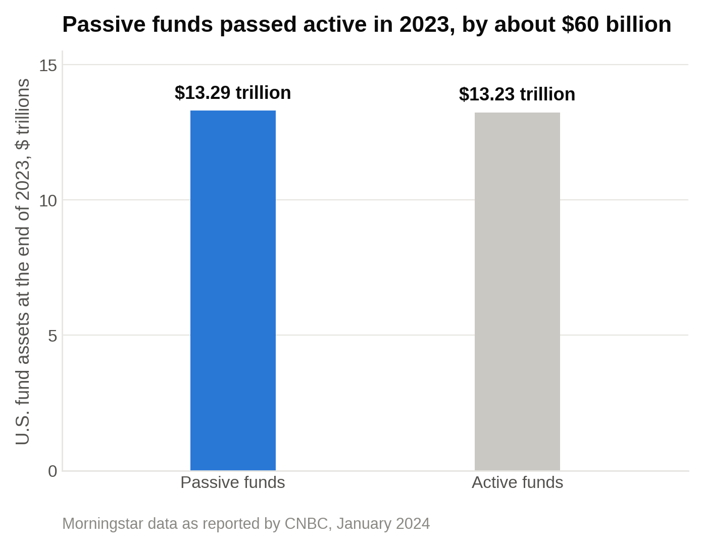
Passive funds held $13.29 trillion of U.S. fund assets at the end of 2023 against $13.23 trillion in active funds, by Morningstar's count as reported by CNBC in January 2024.

1. Asset management is a different job from banking and from hedge funds, and the interview shows it
"Asset management" covers a lot of different jobs, and your interview depends on which one you're sitting for. Here are the four splits that matter.

Long-only versus long/short

Most of the firms below run long-only money. That means the fund buys stocks or bonds it thinks will rise and holds them. It can't bet against a stock (short it), and it usually stays almost fully invested, because the client is paying for exposure to the market, not for the manager to sit in cash.

The fund is judged against a benchmark, an index like the S&P 500 that represents the market the fund is supposed to beat. Say a large-cap fund returns 12 percent in a year while the S&P 500 returns 15 percent. The fund made money, and the manager still underperformed by 300 basis points (a basis point is one hundredth of a percentage point, so 3 percentage points is 300 basis points). Clients compare that gap over three and five years and move money accordingly.

Two things follow for your interview. First, a long-only analyst thinks in years, not quarters. The question is "what is this business worth in three to five years and why is the market paying less than that today," not "what happens at next month's earnings." Second, the analyst has to weigh every idea against the index. Owning a stock at 3 percent of the fund when it's 1 percent of the benchmark is an active bet (an "overweight"); not owning a big index stock at all is also a bet (an "underweight"). A long-only interviewer wants a stock you'd hold for three years, with the downside worked out first, because the fund can't hedge and can't short.

Hedge funds are a different interview. Multi-manager platforms want a thesis with a catalyst in the next three to twelve months and a hedge against it, and macro funds like Bridgewater ask about economies rather than companies (our Bridgewater internship guide walks that process). If you're prepping for both sides, our guide to breaking into a hedge fund covers the hedge fund one.

Fundamental versus quantitative

A fundamental analyst studies one company at a time: reads the 10-K (the annual report filed with the SEC), listens to earnings calls, talks to customers and competitors, builds a model, decides what the stock is worth. A quantitative team builds statistical models that rank thousands of stocks on measurable traits (how cheap, how profitable, how fast estimates are rising) and trades the whole ranking.

Almost every undergrad investing internship at the firms below is fundamental. A few have separate quant tracks: BlackRock's systematic groups, T. Rowe Price's quantitative equity internship, Vanguard's quantitative equity group, PIMCO's quant and PhD programs [VERIFY: each firm's quant track names for the 2028 cycle]. Quant interviews ask probability, statistics and coding, not a stock pitch. Read the posting before you prep.

Equity versus fixed income

Equity analysts cover stocks. Fixed income analysts cover bonds: government debt, corporate debt, mortgages, municipal bonds. The two interviews share the fit questions and split on the technicals.

PIMCO is mostly a bond manager. BlackRock, Fidelity, T. Rowe Price, Wellington and the bank-owned managers run both. Fidelity's fixed income research sits in Merrimack, New Hampshire; Morgan Stanley Investment Management's fixed income internship is in Boston; Neuberger Berman's high yield research interns sit in Chicago [VERIFY: locations per each firm's postings]. A fixed income interview will ask you what happens to a bond's price when rates rise, what duration measures, and why a company's bond yields more than a Treasury. Section 6 walks each of those with numbers.

Multi-manager systems versus star managers

Lynch was a star manager: one person, one fund, one track record. Most big firms moved away from that model. Capital Group, the Los Angeles firm behind the American Funds, has run the alternative since 1958, when Jon Lovelace Jr. split each fund among several portfolio managers [VERIFY: Capital Group history, 1958 per Wikipedia and Capital Group's own description]. In what Capital Group calls The Capital System, "multiple portfolio managers" run slices of the same fund and "share insights but make their own investment decisions." Research analysts run a slice too (Capital Group calls it the research portfolio, and it's often about a fifth of a fund), so the people writing the reports have real money on their calls.

Why this matters for you: at a multi-manager shop, the interview looks hard at how you take in a view you disagree with. The job is to hold your own opinion while twelve colleagues hold theirs. At a firm built around a few senior managers, the interview looks more at whether you can feed one person's process fast and accurately. Ask in your networking calls which kind of shop you're interviewing with, and tune the "tell me about a time you changed your mind" story accordingly.

Two more numbers set the scene. John Bogle launched the first index mutual fund at Vanguard on August 31, 1976; it aimed to raise $50 million to $150 million and brought in a little more than $11 million, which the press called "Bogle's Folly" [VERIFY: Vanguard's own 50-year history page]. Fifty years later, BlackRock, the largest manager in the world, reported $15.3 trillion under management at the end of June 2026 [VERIFY: BlackRock Q2 2026 results, July 15, 2026]. Index funds went from a joke in 1976 to the majority of U.S. fund assets by 2023, and that shift is why active managers interview so carefully for every analyst seat.

2. The firms that hire undergrads into asset management, and when the next cycle opens
Here's what each program looked like in the most recent cycle, checked against each firm's own pages or postings. Dates and pay move every year, so every line carries a tag. Read the pattern more than the dates: most investing internships are for the summer before senior year, and the applications open anywhere from eighteen months to nine months ahead.

The large independent managers

- BlackRock. The Summer Internship Program runs nine weeks from June to August. The 2027 program took undergraduates graduating between September 2027 and July 2028, let candidates pick up to two functions (portfolio management and investment research are both on the list), and paid $40.87 to $60.10 an hour in New York and California depending on the function [VERIFY: 2028 program eligibility, pay and open date on BlackRock's careers site]. After you apply, BlackRock sends a pre-interview assessment that you have up to five days to complete, or the application is withdrawn.
- Fidelity. Fidelity's asset management internships are ten weeks and run on their own calendar, separate from the firm's general summer internships. The Equity Research Associate Internship in Boston takes sophomores for the summer after junior year, and Fidelity says the Boston equity application window for 2028 internships opens in winter 2027 [VERIFY: Fidelity's asset management internship page for the 2028 window]. Interns "conduct stock analysis, build financial models, perform proprietary research, and pitch recommendations." The Fixed Income Research Associate Internship in Merrimack, New Hampshire, takes juniors, and Fidelity's page says recruiting for the 2028 internships runs in spring 2027 [VERIFY: Fidelity's asset management internship page for the fixed income window].
- T. Rowe Price. The Equity Research Summer Internship in Baltimore is ten weeks. The Summer 2027 posting took students graduating between December 2027 and June 2029 with a 3.5 GPA minimum, and interns "conduct fundamental research on an assigned industry and 1 to 2 companies," build three-statement models, and present ratings to investment professionals [VERIFY: Summer 2028 posting and GPA cutoff]. T. Rowe says most internship postings go up in the fall. The stated goal is a return offer into the full-time Associate Analyst program, and rising juniors who do well can get a second summer.
- Capital Group. The Capital Associates Program is a three-year rotational program for new graduates, with a ten-week CAP summer internship for juniors. U.S. internship applications open in January; the full-time program opens in late summer [VERIFY: January 2027 open date for the Summer 2028 internship]. Cohorts sit in Los Angeles, London and Singapore, and rotations include investment research projects, quantitative analytics and company reviews.
- Wellington Management. Wellington's investing path for undergraduates is the Early Career Investor Research Associate program, a full-time rotational role of up to five years supporting analysts and portfolio managers in Boston, London, Hong Kong and Singapore; applications have opened in August [VERIFY: 2027 open date]. The firm also runs a ten-week undergraduate summer internship in Boston, Chicago and San Francisco, with applications opening in September for the following summer [VERIFY: 2028 cycle timing on Wellington's campus programs page]. Details sit on Wellington's careers page.
- PIMCO. The Summer Analyst Program is for undergraduates "in their second-to-last year of study," and PIMCO calls its summer program "a primary pipeline" into the full-time Analyst Program. The 2027 postings, including a trading analyst role in Newport Beach that works "alongside Portfolio Managers on the desk," were up by early September 2026 [VERIFY: Summer 2028 postings and tracks].
- Vanguard. Vanguard's investing entry point is the Investment Management Development Program, a two-year program of four six-month rotations through its Investment Management Group in Malvern, Pennsylvania, with a 3.5 GPA requirement. The most recent posting was for an August 2027 start [VERIFY: whether Vanguard posts a 2028 class and a summer internship alongside it]. Rotations have included fixed income trading, manager research and municipal credit research.
- Invesco. The nine-week Summer Internship Program posts by business area on a rolling basis. Investments, ETFs, real estate and risk roles went up in August for the 2027 class, which took undergraduates graduating in 2028 [VERIFY: August 2027 open date for the 2028 class]. Offices include Atlanta, New York, Dallas, Houston and Downers Grove.
- Franklin Templeton. The Summer Internship Program runs 8 to 12 weeks, takes rising juniors and seniors in the U.S., and recruits from October to December. The two-year Futures rotational program for new graduates recruits September to December and considers former interns first [VERIFY: 2028 cycle timing and whether an investment management track is posted].

The bank-owned managers

- Goldman Sachs Asset Management. GSAM sits inside Goldman's Asset & Wealth Management division, and you apply through the firm's Summer Analyst Program, usually in your third or second-to-last year. Goldman opened 2027 applications for select businesses in the summer of 2026 [VERIFY: 2028 cycle open and close dates]. Our GSAM interview guide covers the division's own questions.
- J.P. Morgan Asset Management. The Asset Management Summer Analyst Program has an Investments track and a Client track. The 2027 Investments posting took students graduating between December 2027 and June 2028, listed New York, Columbus, Indianapolis and Los Angeles, named teams across equities, fixed income, alternatives, liquidity, multi-asset and ETFs, opened January 7, 2026, and closed October 1, 2026 [VERIFY: 2028 posting dates and locations].
- Morgan Stanley Investment Management. The 2027 Investment Management Summer Analyst Program was ten weeks starting in June, one week of training then nine on a team, for students graduating between December 2027 and June 2028, with postings by team (fixed income in Boston, private credit and equity in New York) [VERIFY: 2028 postings]. Morgan Stanley also posted a 2027 Investment Management Sophomore Summer Analyst Program in New York for students graduating between December 2028 and June 2029, with resumes due September 25, 2026 and pay of $36.06 an hour [VERIFY: whether the sophomore program repeats for 2028].

The research-driven independents

- Neuberger Berman. An employee-controlled firm that posts summer internships by team. The 2027 Non-Investment Grade Fixed Income Summer Research Analyst Internship in Chicago wanted December 2027 or spring 2028 graduates with a 3.5 GPA and paid $40 an hour [VERIFY: 2028 postings]. Openings sit on the firm's careers page.
- Dodge & Cox. The San Francisco firm, 100 percent owned by its active employees, runs a ten-week Investment Associate Internship for rising seniors that pays $10,000 a month plus housing, and interns rotate across industry teams and sit in meetings with company management [VERIFY: 2028 posting and pay]. The Summer 2027 posting had closed by late January 2026, so this one recruits early [VERIFY: 2028 window]. Details are on the firm's careers page.
- Others worth a look. AllianceBernstein runs a ten-week summer internship in Nashville and New York with research and portfolio management placements; MFS in Boston posts an Equity Research Associate Intern role for rising seniors; Loomis Sayles in Boston runs ten-week structured internship programs including one for first-generation students [VERIFY: each firm's 2028 postings].

How to read the calendar

If you're a sophomore today, your internship is Summer 2028, and the pattern above says the windows will open between January 2027 (Capital Group, Fidelity's Boston equity group, J.P. Morgan) and fall 2027 (BlackRock, PIMCO, T. Rowe Price, Invesco), with Fidelity's fixed income group in between in spring 2027 and Dodge & Cox closing by the following January [VERIFY: every open date against the firm's site in late 2026]. The earliest asset management windows open about eighteen months before the internship, so a sophomore who waits for junior fall has already missed the first group. If you're a junior reading this in the fall, several Summer 2027 postings are open now or closed in the last few weeks; apply to what's still open and build the pitch for the final rounds, which run through the winter.

One more thing the postings don't say. A network inside these firms matters more than it does in banking, because the classes are small and portfolio managers often get a say in who joins their team. One conversation with an analyst on the team you're applying to, before the application goes in, is worth more than ten with recruiters. If you're weighing the sell-side version of this work, our comparison of equity research and investment banking covers how those paths feed into buy-side seats later.

3. The stock pitch is the center of an asset management interview, and the long-only version has its own shape
Every strong pitch answers the same seven questions. Learn the order, then fill it in. Where the long-only version differs from a hedge fund pitch, I've said so.

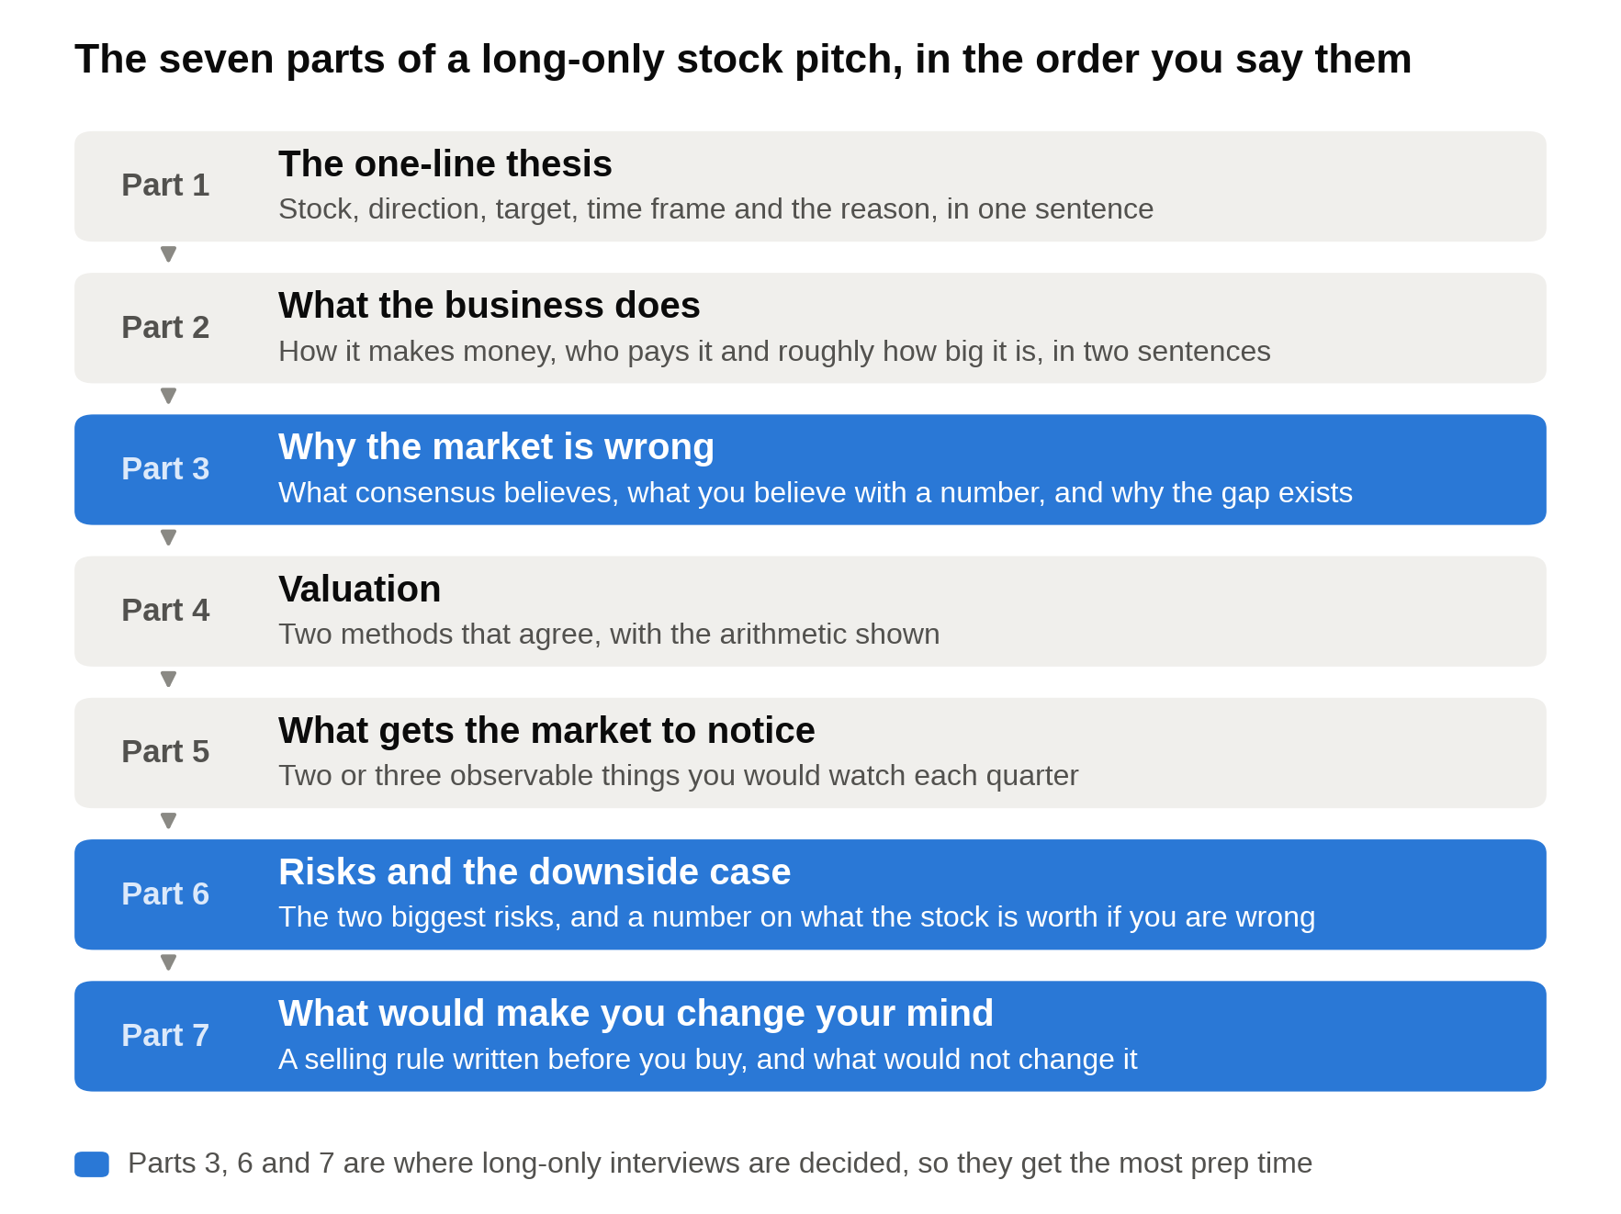
Say the seven parts in this order; the blue ones are where a long-only interviewer spends the most time, and where most undergrads have the least.

Part 1: The one-line thesis

"I'd buy [company] at $40. I think it's worth about $57 in three years, roughly 12 percent a year, because [the reason, in one clause]."

That sentence gives the interviewer the stock, the direction, the target, the time frame and the reason. Section 4 opens with the filled-in version. If you can't fit the reason into one clause, you don't have a thesis yet.

Part 2: What the business does

One or two sentences on how the company makes money, who pays it and for what, and roughly how big it is. Skip the mission statement. An interviewer who can't picture the business after two sentences will stop listening to the valuation.

Part 3: Why the market is wrong

This is the part most undergrads skip, and the part the interviewer cares about most. The stock price already reflects what most investors believe. Your job is to say what they believe (usually the average of Wall Street analysts' forecasts, called "consensus," which you can find on Yahoo Finance or a campus Bloomberg terminal), what you believe instead, with a number, and why the gap exists.

The long-only version of "why the gap exists" is usually one of three things: the market is reacting to a short-term problem in a business that's fine long term, the company doesn't break out its best segment so nobody models it, or investors are anchored to a number from two years ago. A hedge fund pitch needs a catalyst to close the gap within a year. A long-only pitch can wait for the business to prove it, as long as you can show the business will keep doing what it's doing.

Part 4: Valuation

Turn your view into a price with two methods that agree, and show the arithmetic. For undergrad interviews that usually means a multiple (price to earnings or enterprise value to EBITDA) applied to your own estimate, not consensus, plus a free cash flow yield or a simple DCF as a cross-check. Section 6 explains each tool from zero; section 4 shows all of them working on one stock.

Part 5: What gets the market to notice

Hedge fund interviewers call these catalysts and want a date. Long-only interviewers ask a softer version: "What has to happen for the market to agree with you?" The answer is usually two or three observable things, like a segment's growth showing up in reported numbers, a cost program landing in the margin, or an equipment cycle stabilizing. Name what you'd watch each quarter.

Part 6: Risks and the downside case

Name the two biggest risks before the interviewer does, and put a number on the downside. A long-only fund can't hedge a bad idea, so the interviewer wants your bear case worked out as carefully as your base case. "If I'm wrong, the stock is worth about $33" is an answer. "There's limited downside" is not.

Part 7: What would make you change your mind

This is the question that decides long-only interviews, because the job is holding a position for years while the market disagrees with you. You need a rule written in advance that separates "the stock fell" from "the thesis broke." Pick one or two measurable signs, like a segment's growth falling below a line for two quarters, and say that if you see them you'd sell, even at a loss. Then say what wouldn't change your mind: a bad quarter for reasons unrelated to the thesis, or the whole market falling. A selling rule written before you buy is the answer that decides most long-only interviews.

Here's why this part matters so much. A student I worked with last year, call him Jonah, came to WSG a week after a first round at a long-only shop that hadn't gone well. He'd pitched a short with a three-month catalyst, the kind of idea a hedge fund pod would love. The interviewer said: "We can't short, and we hold things for five years. What do you own?" He didn't have one. We spent the next two weeks building a single long idea around parts 3, 6 and 7 above, and he spent most of his next interview on what would make him sell. That one went to a final round and an offer.

4. A worked sample pitch, with every number shown
Harlow Dental Supply isn't a real company. Every number below is made up to show the mechanics, and I've kept them round so you can follow the arithmetic. For your own pitch, use a real company with numbers from its filings.

The setup

- Share price: $40. Shares outstanding: 150 million. Market cap (price times shares): $6.0 billion.
- Debt: $1.5 billion. Cash: $0.3 billion. Net debt: $1.2 billion. Enterprise value (market cap plus net debt): $7.2 billion.
- Last twelve months' revenue: $6.0 billion. Consumables (gloves, composites, impression material, the things a dental office reorders every month) are $4.2 billion, or 70 percent. Equipment (chairs, imaging units) is $1.8 billion, or 30 percent.
- EBITDA: $600 million, a 10.0 percent margin. Depreciation and amortization: $90 million. So operating profit (EBIT): $510 million, an 8.5 percent margin.
- Interest expense: $72 million. Tax rate: 25 percent.
- Net income: ($510 million minus $72 million) times 0.75 = $328.5 million. Earnings per share: $328.5 million divided by 150 million shares = $2.19.
- Capital expenditures: $100 million. Increase in working capital: $20 million.

At $40, the stock trades at 40 divided by 2.19 = 18.3 times earnings, and the enterprise value is 7.2 divided by 0.6 = 12.0 times EBITDA. Over the past five years it averaged about 20 times earnings (illustrative).

The one-line thesis

"I'd buy Harlow at $40 with a three-year value of about $57, roughly 12 percent a year, because 70 percent of its revenue is recurring consumables that are still growing while the market prices the whole company like a cyclical equipment seller."

What the business does

Harlow distributes supplies and equipment to roughly 40,000 dental practices in the U.S. (illustrative). A dentist's office doesn't want to manage 300 suppliers, so it orders through one distributor that delivers weekly. Consumables are small, frequent orders that keep coming regardless of the economy. Equipment is big, rare orders that dentists delay when financing gets expensive.

Why the market is wrong

The stock fell from about $52 to $40, a 23 percent drop, after equipment revenue fell 12 percent over the past year as practices put off buying chairs and imaging units. Consensus now models flat revenue and a flat margin next year, which gives earnings per share of about $2.19 again. The market is pricing the whole company as if growth is over.

Here's what I think consensus is missing, in three parts.

First, 70 percent of the business never slowed. Consumables grew 4 percent last year while equipment fell. A dentist who delays a $40,000 chair still orders gloves every month. I model consumables growing 4 percent a year for three years and equipment flat for two years, then up 5 percent in year three. I don't need the equipment cycle to recover for this to work.

Second, the mix shift and a cost program lift the margin. Consumables earn a higher margin than equipment, so as they become a bigger share of revenue the overall margin rises on its own. On top of that, management is consolidating two distribution centers into one and said on the last call that it saves about $30 million a year starting in year two (illustrative). Together I get the operating margin going from 8.5 percent to 8.6, 9.0 and 9.2 percent over three years.

Third, the company is buying back stock while it's cheap. It has a $400 million repurchase authorization (illustrative), enough to retire about 2 percent of the shares a year at this price. Fewer shares means each share gets a bigger slice of the same profit.

The projections

 | Last 12 months | Year 1 | Year 2 | Year 3
Consumables revenue ($M) | 4,200 | 4,368 | 4,543 | 4,724
Equipment revenue ($M) | 1,800 | 1,800 | 1,800 | 1,890
Total revenue ($M) | 6,000 | 6,168 | 6,343 | 6,614
Operating margin | 8.5% | 8.6% | 9.0% | 9.2%
EBIT ($M) | 510 | 530 | 571 | 609
Interest ($M) | 72 | 72 | 72 | 72
Net income at 25% tax ($M) | 329 | 344 | 374 | 402
Shares (M) | 150.0 | 147.0 | 144.1 | 141.2
EPS | $2.19 | $2.34 | $2.60 | $2.85

Walk one row so the interviewer sees you built it. Year 1 consumables: $4,200 million times 1.04 = $4,368 million. Add flat equipment of $1,800 million for $6,168 million of revenue. Times an 8.6 percent margin = $530 million of EBIT. Subtract $72 million of interest, which leaves $458 million. Take off 25 percent tax and you have $344 million of net income. Divide by 147 million shares (150 million less 2 percent) and EPS is $2.34, about 7 percent above the $2.19 consensus for next year. By year three, EPS is $2.85, about 30 percent above where it is today.

Valuation, three ways

Method 1: Price to earnings. Apply the stock's own five-year average multiple of 20 times to year-three EPS of $2.85: 20 times 2.85 = $57. From $40, that's 42.5 percent upside over three years, or about 12.5 percent a year compounded (1.425 to the one-third power is 1.125). If the multiple never recovers and stays at 18.3, the value is 18.3 times 2.85 = $52, still 30 percent upside. Most of the upside in this pitch comes from earnings I can trace line by line, not from hoping the market pays a higher multiple.

Method 2: Free cash flow yield. Free cash flow is the cash left after the company pays its bills and reinvests in the business. Here: net income of $328.5 million, plus $90 million of depreciation (a non-cash expense, so add it back), minus $100 million of capital expenditures, minus a $20 million increase in working capital = $298.5 million, or $1.99 a share. Divide by the $40 price: a 5.0 percent free cash flow yield.

Now the honest part. The 10-year Treasury yielded about 5.3 percent at the end of September 2026 [VERIFY: FRED 10-year constant maturity, 5.26 percent on September 29, 2026]. On yield alone, a 5.0 percent cash yield from a stock isn't cheap against a 5.3 percent yield from a government bond. The case rests on growth: in my base case, free cash flow per share goes from $1.99 to about $2.62 by year three, close to 10 percent a year, and a Treasury coupon can't grow. I'd say exactly that in the interview before anyone asks, because it shows I compared the stock to the alternative.

Method 3: A simple DCF as a cross-check. A discounted cash flow model values the business as the sum of the cash it will produce, with each future year's cash shrunk ("discounted") back to today, because a dollar in five years is worth less than a dollar now. I project unlevered free cash flow (cash before interest, so it belongs to lenders and shareholders together) for five years, add a terminal value for everything after year five, discount it all at 7.5 percent, subtract net debt and divide by shares.

 | Year 1 | Year 2 | Year 3 | Year 4 | Year 5
EBIT ($M) | 530 | 571 | 609 | 630 | 652
After 25% tax ($M) | 398 | 428 | 456 | 472 | 489
Plus D&A, less capex, less working capital ($M) | (30) | (30) | (32) | (34) | (36)
Unlevered free cash flow ($M) | 368 | 398 | 424 | 438 | 453

Years four and five assume 3.5 percent revenue growth and a 9.2 percent margin. The terminal value treats year-five cash flow as growing 3 percent a year forever: $453 million times 1.03, divided by (7.5 percent minus 3 percent), is about $10.4 billion, which discounted back five years is about $7.2 billion. Add the present value of the five yearly cash flows, about $1.7 billion, for an enterprise value of about $8.9 billion. Subtract $1.2 billion of net debt and divide by 150 million shares: about $51 a share today, 28 percent above the price.

Say the sensitivity out loud too. At an 8.5 percent discount rate and 2.5 percent terminal growth, the same cash flows are worth about $37 a share, below today's price. Terminal value is around 80 percent of the total either way. A DCF moves more on the discount rate and terminal growth than on anything in your model, so lead with the multiple and use the DCF as a cross-check, not as proof. Our DCF walk-through covers the full seven steps if you want the mechanics in more depth.

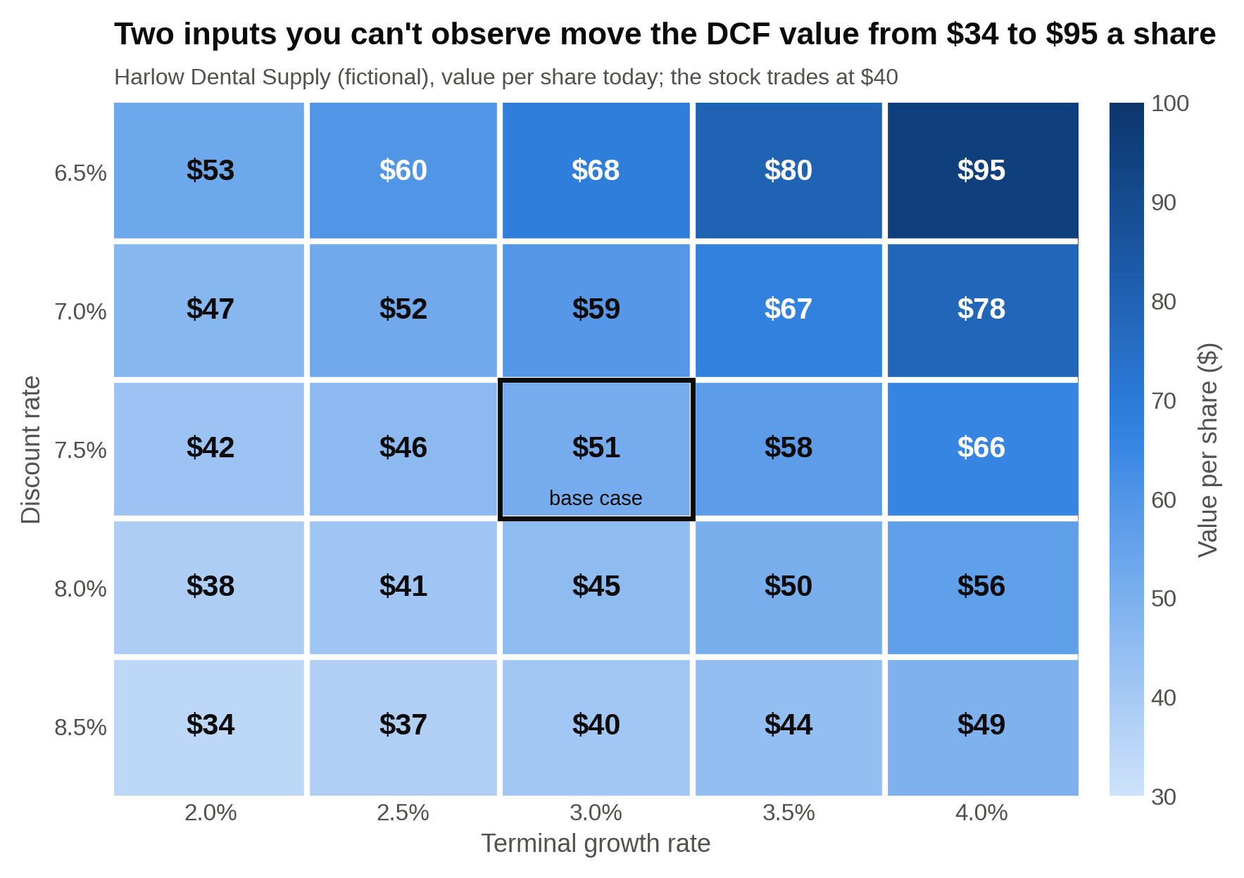
The base case is $51 at 7.5 percent and 3 percent growth; move one row down and one column left to 8.5 and 2.5 percent and the same cash flows are worth $37, below the $40 price.

What gets the market to notice

- Consumables growth printed separately each quarter. If it holds at 4 percent while equipment stays weak, the "it's all cyclical" story gets harder to hold.
- The year-two margin step-up from the distribution center consolidation. Once $30 million shows up in reported operating income, consensus has to raise its numbers.
- Equipment orders stabilizing. I'd watch the backlog number management gives each quarter. I don't need it to grow; I need it to stop falling.

Risks and the downside case

- Equipment keeps falling. If financing stays expensive, equipment could drop another 10 percent next year instead of flattening.
- A national competitor cuts consumables pricing to take share, and Harlow's 4 percent growth becomes 2 percent.
- The consolidation savings don't show up, or get spent elsewhere.

Put them together into a bear case: consumables grow 2 percent a year, equipment falls 10 percent then stays flat, the margin sits at 8.0 percent, and buybacks continue. Year-three EPS comes out around $2.20, and a market that has lost patience pays 15 times: about $33 a share, 17.5 percent below today. So the pitch is roughly 42 percent up against 17 percent down, about 2.4 to 1. If I put 65 percent odds on the base case and 35 percent on the bear case, the probability-weighted value is 0.65 times $57 plus 0.35 times $33, about $48.60, or 21 percent above the price.

What would make me change my mind

If consumables growth drops below 2 percent for two straight quarters, the thesis is broken, because that would mean practices are cutting volumes rather than delaying equipment. I'd sell. Same if the year-two margin doesn't move at all after the consolidation is done. What wouldn't change my mind: another weak equipment quarter, which I already model, or the stock falling with the market.

Where it fits in the portfolio

In a 50-stock fund, an equal weight is 2 percent. I'd start Harlow at 2 percent, which is a meaningful overweight since a $6 billion company is a rounding error in a large-cap benchmark, and I'd be willing to add if the stock fell for reasons unrelated to the thesis. I'd also note what else in the fund is exposed to dental or medical equipment demand, so the fund doesn't carry the same bet three times.

The two-minute version

"I'd buy Harlow Dental Supply at $40. I think it's worth about $57 in three years, about 12 percent a year. It's a dental distributor the market is pricing like a cyclical equipment company, at 18 times earnings against its own 20 times average, after equipment sales fell 12 percent. But 70 percent of revenue is consumables that grew 4 percent through the slowdown. With consumables at 4 percent, equipment flat, a 70 basis point margin lift from mix and a distribution center consolidation, and 2 percent a year of buybacks, EPS goes from $2.19 to $2.85 in three years. Twenty times that is $57, and a DCF at 7.5 percent lands around $51 today. The free cash flow yield is 5 percent and growing close to 10 percent a year. My bear case is about $33, so it's 2.4 to 1. I'd sell if consumables growth fell below 2 percent for two quarters, because that would mean the recurring business isn't recurring."

About 160 words. Everything above it is what you need for the follow-ups.

5. Market view questions, with sample answers
Every asset management interview asks what you think about the market, and most undergrads answer with a vague forecast and no numbers. The interviewer wants a view with a mechanism and the three or four numbers that back it. Update these the morning of the interview.

"Where's the market right now, and is it expensive?"

Have three numbers: the S&P 500 level, its forward price to earnings ratio, and the 10-year Treasury yield. FactSet put the S&P 500 at 19.2 times the next twelve months' earnings on September 25, 2026, below its five-year average of 19.8 and above its ten-year average of 19.0, with analysts expecting 2027 earnings to grow 15.4 percent [VERIFY: FactSet Earnings Insight the week of publication]. The 10-year yielded about 5.3 percent [VERIFY: FRED, week of publication].

Sample answer: "On price to earnings, the market is about in line with its own history, at roughly 19 times forward earnings. What makes me cautious is that the 10-year yields around 5.3 percent, so stocks' earnings yield (one divided by 19.2, about 5.2 percent) is roughly the same as a government bond's. Investors are being paid very little extra to take stock risk. That tells me returns from here have to come from the 15 percent earnings growth analysts expect, not from the multiple rising. If that growth comes in closer to 8 percent, the market has a hard time rising from here. So I'd rather own companies whose earnings growth I can trace to specific drivers than own the index." A market view is a mechanism plus two numbers, never a prediction of where the index closes in December.

"If the Fed cuts rates, what happens to the stocks you cover?"

Walk the chain. Lower rates make future cash flows worth more today, because you discount them at a lower rate, and that helps companies whose profits sit far in the future more than companies earning most of their cash now. Lower rates also reduce interest costs for indebted companies and make financing cheaper for their customers. For Harlow, that second effect is the one that matters: dentists finance equipment, so a cut would likely speed up the equipment recovery I'm not even counting on. Say which link in the chain matters for your stock, not all of them.

"Why should anyone pay for active management?"

A fair question at a firm that charges for it, and a trap if you dodge it. The honest answer to the active-versus-passive question concedes the index fund's record first and then names where active research still earns its fee. It acknowledges the record (most active large-cap managers trail their benchmark over ten years, by Morningstar's regular scorecards [VERIFY: latest Active/Passive Barometer figure]) and then explains where active still earns its fee: smaller companies with little analyst coverage, bonds, where indexes are weighted toward the biggest borrowers rather than the best credits, and periods when the index is concentrated in a handful of names. Then connect it to why you want the job: you want to be measured against that bar.

"Which sector would you overweight for the next three years, and why?"

Pick one sector, give one structural reason and one valuation reason, and name a stock in it. "I'd overweight industrial distributors like Harlow because the market is pricing a cyclical downturn into businesses with recurring revenue, and they trade below their own history while the index trades about in line with its." Avoid "technology, because AI." Every candidate says it, and it has no valuation reason attached.

6. Technical questions, explained from zero
Asset management technicals are lighter than banking technicals and heavier on judgment. You'll rarely be asked to walk a $10 depreciation change through three statements, though you should be able to. You'll often be asked why one multiple suits one company and not another. Each tool below is explained from scratch, then applied.

Price to earnings

The P/E ratio is the share price divided by earnings per share. If a stock is $50 and next year's EPS is $2.50, the forward P/E is 50 divided by 2.50 = 20. Investors are paying $20 for each $1 of next year's profit. "Forward" uses next year's estimate; "trailing" uses the last twelve months.

What it's good for: quick comparisons between profitable companies with similar amounts of debt. What breaks it: net income is after interest, so two identical businesses with different debt loads show different P/Es, and a company with no earnings has no P/E at all. In an interview, always say which year's earnings you're using and why you picked the multiple you applied (its own history, its peers, or its growth rate).

Enterprise value to EBITDA

Enterprise value is the price of the whole company: market cap plus debt minus cash. You add debt because a buyer would take it on; you subtract cash because the buyer gets it. EBITDA is earnings before interest, taxes, depreciation and amortization, a rough measure of operating cash profit before anyone decides how the company is financed.

Here's why the pairing matters. Company A has a $1,000 million market cap, no debt, $200 million of EBITDA and $120 million of net income. Company B has a $600 million market cap, $400 million of debt, the same $200 million of EBITDA, and $100 million of net income (lower, because it pays interest). Both have a $1,000 million enterprise value and trade at 5.0 times EBITDA. On P/E, A is at 8.3 times and B is at 6.0 times, and B looks cheaper only because it's borrowed more. EV/EBITDA compares two businesses as businesses, before financing, which is why analysts use it to compare companies with different debt loads. Its weakness is that EBITDA ignores the capital spending a company needs just to stay in place, so it flatters asset-heavy businesses. Never divide enterprise value by net income or market cap by EBITDA; the top and bottom have to belong to the same group of investors (enterprise value and EBITDA belong to lenders and shareholders together, market cap and net income to shareholders alone).

Free cash flow yield

Free cash flow is the cash a business generates after capital spending and working capital, the money that could go to dividends, buybacks or debt paydown. Divide free cash flow per share by the price and you get a yield you can compare directly to a bond. Harlow's $1.99 of free cash flow per share on a $40 stock is a 5.0 percent yield.

The interview use: compare it to the 10-year Treasury and then talk about growth. A 5 percent cash yield that grows 10 percent a year is worth far more than a 5.3 percent coupon that doesn't. A 5 percent yield that's shrinking is a value trap. Flip the ratio (price divided by free cash flow) and you have a multiple that works like the P/E but uses cash instead of earnings, which makes it harder for accounting choices to flatter.

DCF basics

A DCF adds up the cash a business will produce over its life, with later years counted for less. Three inputs do most of the work.

- The cash flows, usually five years of projections.
- The discount rate, which is the return investors demand for taking this company's risk. For a stable business today that's often 7 to 9 percent; riskier businesses get higher rates, which shrink future cash more.
- The terminal value, which captures every year after the projection period in one number. The common shortcut: take the last year's cash flow, grow it one more year at a long-run rate (2 to 3 percent), and divide by the discount rate minus that growth rate.

A small example. Cash flow of $105 million next year growing 5 percent a year for five years, discounted at 9 percent, is worth about $448 million today. A terminal value with 2.5 percent growth after year five is about $2.0 billion, or $1.3 billion once discounted. Total: about $1.76 billion, of which about 75 percent is the terminal value. That share is normal, and it's the reason an interviewer will push on your discount rate and terminal growth before anything else. Know what one percentage point on each does to your answer; in the Harlow example, moving the discount rate from 7.5 to 8.5 percent with the same 3 percent terminal growth took the value from $51 to about $40.

For fixed income roles: price versus yield

A bond is a loan with a fixed schedule: you pay a price today, collect a fixed coupon each year, and get the face value (usually $1,000) back at maturity. The yield is the return you earn if you hold it to maturity at the price you paid.

Price and yield move in opposite directions, and here's the mechanism. Say a 5-year bond pays a 5 percent coupon, $50 a year, and was issued at $1,000 when market rates were 5 percent. The week after you buy, rates rise to 6 percent, so new bonds pay $60 a year. Nobody will pay $1,000 for your $50-a-year bond when they can get $60 for the same money. Your bond's price falls until its yield matches: for a 5-year bond that's about $958. The buyer collects $50 a year plus a $42 gain when it pays back $1,000, which works out to the 6 percent the market now demands. If rates fell to 4 percent instead, the bond would rise to about $1,045. When interest rates rise, existing bond prices fall, because the fixed coupon has to be discounted to compete with the new, higher rates.

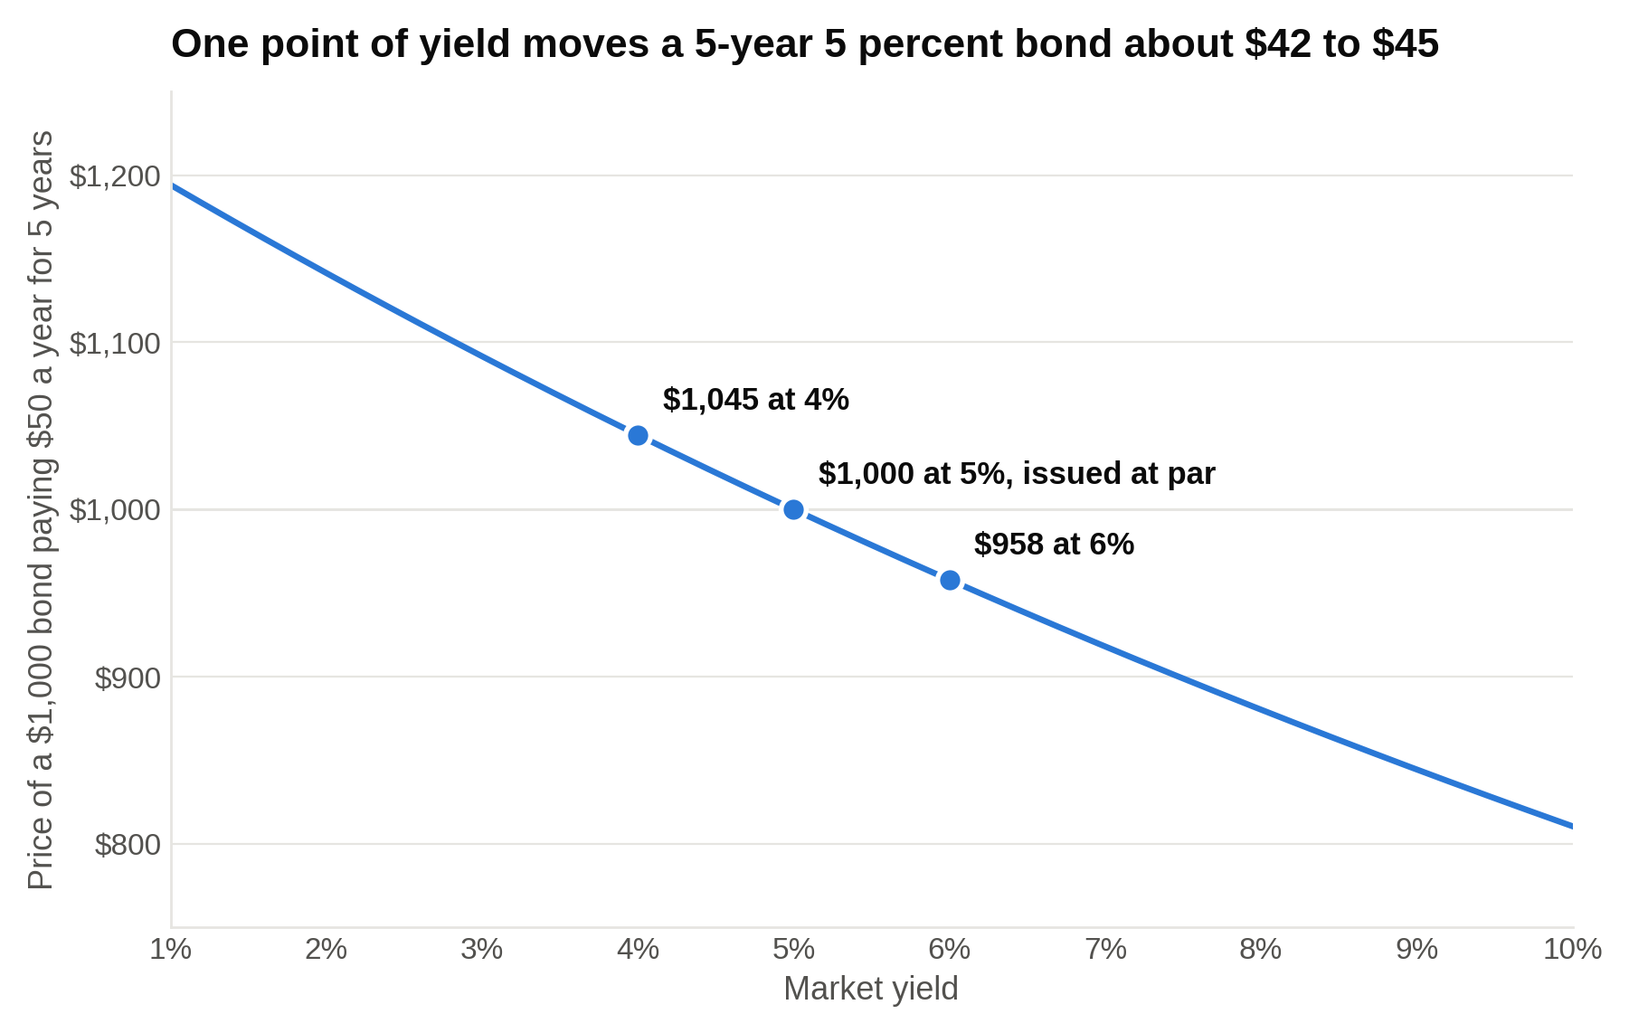
The same one point move in yields takes $42 off the price going up and adds $45 coming down; duration, in the next section, is the shortcut for that slope.

Duration

Duration measures how much a bond's price moves when yields move. The rule of thumb: price change is roughly minus the duration times the change in yield. The 5 percent, 5-year bond above has a modified duration of about 4.3, so a 1 percentage point rise in yields cuts its price by about 4.3 percent, close to the $42 drop we worked out exactly. A 30-year 5 percent bond has a duration around 15, so the same 1 point rise costs it about 15 percent of its price.

Two things make duration longer: more years to maturity (cash flows are farther away, so a rate change compounds over more years) and lower coupons (less of your money comes back early). A zero-coupon bond's duration equals its maturity, because every dollar arrives at the end. Portfolio managers talk about being "long duration" when they expect rates to fall (they want bonds that gain the most) and "short duration" when they expect rates to rise. If a fixed income interviewer asks what you'd do if you expected the Fed to cut, the answer starts with "I'd add duration."

Credit spreads

A corporate bond yields more than a Treasury of the same maturity because the company might not pay you back. The difference is the credit spread, quoted in basis points. If the 5-year Treasury yields 5.0 percent and a 5-year bond from a company rated BB yields 7.5 percent, the spread is 250 basis points.

What the spread pays you for: the chance of default times how much you'd lose if it happened. If you think there's a 2 percent chance a year the company defaults, and bondholders would recover 40 cents on the dollar in a bankruptcy, your expected loss is 2 percent times 60 percent, or 1.2 percent a year. A 250 basis point spread covers that with about 130 basis points to spare, which compensates you for the bond being harder to sell than a Treasury and for the risk that your 2 percent estimate is wrong. If the company's results worsen and investors demand a 350 basis point spread, the bond's yield rises 100 basis points and its price falls by roughly its duration, about 4 percent for our 5-year example, even though nothing has defaulted. A credit analyst gets paid for deciding whether the spread covers the expected loss, which is why fixed income interviews ask about default probability and recovery before they ask about yield.

Accounting still shows up once

Expect one three-statement question, often about depreciation or inventory, mostly to confirm you can keep three things straight at once. Practice the depreciation walk (expense falls on the income statement, add it back on the cash flow statement, assets shrink on the balance sheet) and the inventory walk until they're automatic. Keep that to a day of prep; the pitch deserves the rest.

7. Fit questions: why asset management, why long-only, what you read
Fit questions at a long-only firm carry more weight than at a bank, because the firm is hiring someone it hopes will stay for a decade, not a two-year analyst class.

Each answer below is in a student's voice. Make the details yours.

"Why asset management and not investment banking?"

The best answer to "why asset management" shows you've already been doing the job in some form, with a record you can describe. The reason should be about the work rather than the hours. Sample: "I've run a paper portfolio since freshman spring and written a one-page memo for every position, with a thesis, a valuation and a line about what would make me sell. Nine ideas so far; five are ahead of the S&P and four are behind, and the four taught me more. What I want is to be measured on whether my judgment about a business was right, over years. Banking is about getting a client's transaction done, and the people I've talked to there are measured on execution, not on being right. I'd rather be measured on being right."

"Why long-only and not a hedge fund?"

Here the firm is checking that you understand what it does and want that specifically. Sample: "Two reasons. The first is time horizon. The work I enjoy most is understanding a business well enough to hold it through a bad year, which is a different skill from trading around a quarter, and it fits how I think. The second is the client. Long-only firms manage pensions and 401(k) money for people who can't afford a blow-up, and that constraint, protect the downside first, is the discipline I want to learn in. I've read about [the firm's] approach to [a specific thing from the firm's own materials], and that's the version of investing I want to practice."

"What do you read?"

Name specific things and say what you took from one of them recently. A real answer: the Wall Street Journal's markets section most mornings, two or three company 10-Ks a month in the industry you follow, the quarterly letters of one or two investors you respect, and one book you can discuss. For books, pick something you've actually finished; Lynch's "One Up on Wall Street" (1989) is a fair choice for this interview if you can talk about his point that the store visit is where the work starts, not where it ends. Avoid "I follow a lot of finance accounts." Interviewers hear that daily.

"What's a stock you'd never own, and why?"

This is a reverse pitch, and it tests the same skills. Pick a well-known company and give a business reason, not a moral one: a company whose product is being replaced, whose growth depends on a single customer, or whose accounting you can't follow. Then show the honesty the job needs: "I could be wrong if [specific thing]." Sample: "I wouldn't own a company that sells a commodity product and spends more than it earns on capital expenditure to keep up, because the free cash flow never shows up for shareholders. [A specific example in an industry you know.] I'd change my mind if the industry consolidated enough that pricing improved."

"Why this firm?"

A why-this-firm answer that names how the firm invests beats one that names how big it is. For a multi-manager firm like Capital Group, talk about wanting to build your own view while learning from a dozen others. For a research-driven partnership like Dodge & Cox or Wellington, talk about the long tenure of its analysts and what that does for the quality of research. For a bank-owned manager, talk about the specific team and strategy you're interviewing for, by name. Reading what an equity research analyst actually does day to day helps here, because the buy-side analyst job is the same research with a portfolio attached, and interviewers want to hear that you know what the days look like.

8. Behavioral questions in an asset management interview
The behavioral questions are the ones banking prep already covers (teamwork, leadership, a failure), with one addition that long-only firms care about more than anyone else: how you handle being wrong, and how you change your mind. Here are the ones that come up most, with short sample answers.

"Tell me about a time you changed your mind about something important."

They want to see that you can update on evidence without flipping on noise. Sample: "In my investment club I pitched a regional grocer at 12 times earnings as a safe, cheap stock. A sophomore in the club asked how its margins compared to a warehouse club that had just opened two stores in its region. I'd skipped it. I pulled both companies' filings that week, found the grocer's gross margin had fallen three straight years, and withdrew the pitch. What I changed was my process: now every pitch I write has a section on the strongest competitor's numbers alongside the company's." Interviewers reward a changed mind that came with a changed process, because the process is what they're hiring.

"Tell me about an investment or decision that went badly. What did you learn?"

Pick something real and small, own the mistake, and name the rule you set afterward. "I bought a retailer in my personal account after a strong quarter without checking that the margin jump came from a one-time tax benefit. It fell 20 percent at the next report. The rule I set: before I believe any beat, I read the tax line and the footnotes for one-time items." A clean story about a mistake beats a story about a win.

"Tell me about a time you disagreed with a group and held your position."

Long-only investing means holding a view the market disagrees with for a long time. The interviewer wants to see you can do it with evidence rather than stubbornness. Walk the disagreement, the evidence you brought, the outcome, and what you'd do differently. Ending the story with what would have made you back down is what separates conviction from stubbornness in the interviewer's notes.

"How do you handle a project where the result depends on things you can't control?"

An analyst can do everything right and watch a stock fall for a year. Sample: "I separate the decision from the outcome. When I pitch something, I write down what I expect to happen and why, so later I can check whether I was wrong about the business or just early. In my club's year-end review, two of my picks were down, and I could show that in one case the thesis was intact and in the other it had broken. We held the first and sold the second."

"Tell me about a time you worked with someone whose approach was very different from yours."

At a multi-manager firm this one matters a lot. Keep the story about how you used the difference, not how you tolerated it. "A teammate on a case competition built everything bottom-up from unit economics; I started from industry totals. The numbers disagreed by 30 percent. Instead of picking one, we spent a night finding the assumption that drove the gap, a pricing assumption, and the judges said that reconciliation was the strongest part of the deck."

9. The two-week prep plan
Two weeks is enough if the pitch comes first. Here's how I'd split it.

- Days 1 to 2: pick the stock and read everything. Choose a company you can explain from the ground up, ideally $2 billion to $20 billion in market cap so you can find something the market underweights. Read the last 10-K, the last two earnings call transcripts and the proxy statement. Write one page on how the business makes money.
- Days 3 to 4: find the consensus view and your gap. Pull the analyst estimates. Write what the market believes, what you believe, and why the gap exists, in three sentences each. If you can't write why the gap exists in three sentences, pick a new stock now, not on day ten.
- Days 5 to 6: build the numbers. A three-year projection like the Harlow table, a P/E target, a free cash flow yield, and a simple DCF with the sensitivity worked. Keep every number traceable to a line in the filings or an assumption you can defend.
- Day 7: write the bear case and your exit rule. The downside price, the two biggest risks, and the one or two measurable signs that would make you sell.
- Days 8 to 9: technicals. Work the P/E, EV/EBITDA, free cash flow yield and DCF sections above until you can explain each from zero. For a fixed income seat, add price versus yield, duration and spreads, and work the bond example by hand.
- Day 10: market view. Three numbers (index level, forward P/E, 10-year yield), one mechanism, one sector you'd overweight and why. Rewrite it the morning of the interview.
- Days 11 to 12: fit and behavioral. Write your four stories (changed your mind, got something wrong, held a position, worked with a different style) and your why-this-firm answer with one specific from the firm's own materials.
- Day 13: mock interview. Give the two-minute pitch to someone who will ask "why?" five times in a row and "what would make you sell?" at the end. Fix what you stumble on.
- Day 14: update and rest. Refresh the stock price and the market numbers. Don't learn anything new.

The order matters: a candidate with a strong pitch and average technicals beats one with perfect technicals and a weak pitch in almost every asset management interview I've seen.

10. Say this, don't say that
The strongest asset management interview answers trade an adjective for a number, a source or a rule. Each pair below shows the swap.

Walk me through your pitch.
Don't say: "It's a great company with strong management, a big market and a lot of growth ahead."
Say: "Seventy percent of revenue is consumables that grew 4 percent through the slowdown, and consensus models the whole company flat. That gap alone is worth about 7 cents of next year's EPS, and the buyback and the margin program take the total to about 15 cents above consensus."

Why hasn't the market priced this in?
Don't say: "I think people are just missing it."
Say: "The stock fell 23 percent on the equipment numbers, and consensus still models flat revenue next year. The company doesn't break out consumables margin, so the mix shift isn't in anyone's model until it shows up in reported margins."

What would make you change your mind?
Don't say: "I'd reassess if the fundamentals deteriorated."
Say: "If consumables growth falls below 2 percent for two quarters, I'd sell, because that means practices are cutting volume, not delaying chairs. A weak equipment quarter wouldn't change my mind; I already model it."

Why asset management and not banking?
Don't say: "I want to be on the buy side because the hours are better and the work is more intellectual."
Say: "I've kept a written memo on every position I've held since freshman year, and the four that went wrong taught me more than the five that worked. I want a job where I'm measured on whether I was right about a business over years."

What's your view on the market?
Don't say: "I think the market is going to keep going up because the economy is strong."
Say: "At about 19 times forward earnings, the market's earnings yield is roughly the same as the 10-year Treasury's 5.3 percent, so investors are getting very little extra for stock risk. Returns from here have to come from the earnings growth analysts expect, which is why I'd rather own specific companies than the index."

What happens to bond prices if rates rise?
Don't say: "Bond prices go down."
Say: "They fall, and by roughly the duration times the rate move. A 5-year bond with a duration of about 4.3 loses about 4.3 percent of its price if yields rise a full point, because its fixed coupon now has to compete with higher-paying new bonds."

What to do this week
Pick your stock and read its 10-K before anything else. Then write the one sentence from part 1 of section 3: the stock, the direction, the value, the time frame and the reason. If the reason won't fit in a clause, that's what the first week is for. The students who get long-only offers walk in with one idea they can defend for three years, a downside they've priced, and a rule for when they'd sell; everything else in the interview is built on top of that. If you're a sophomore, the earliest windows for your summer open in a few months, and the pitch takes longer to build than the application does.

